Gym Management System Using Salesforce
Project Overview:
The Gym Management System is a Salesforce-based application designed to manage gym operations efficiently. The system helps maintain information about gym members, trainers, membership plans, and payments.
Salesforce Implementation
The application is developed using Salesforce custom objects and automation features.
The main objects created are:
- Trainer Object
- Gym Member Object
- Membership Object
- Payment Object
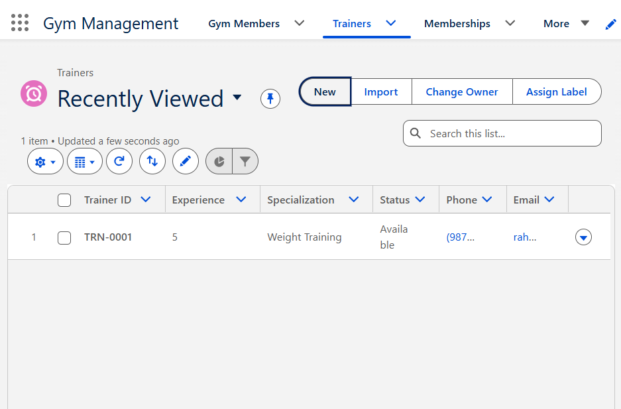
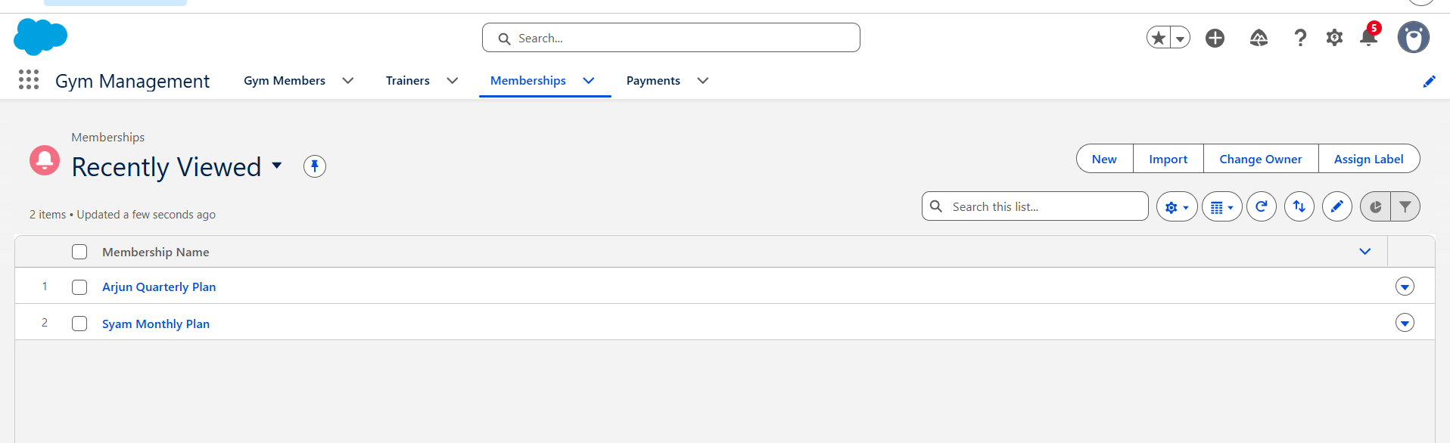

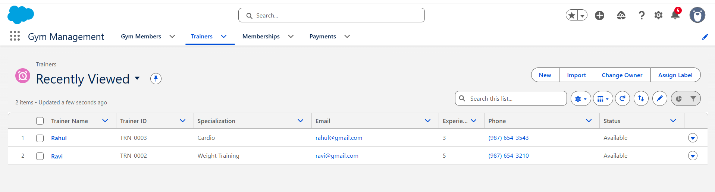

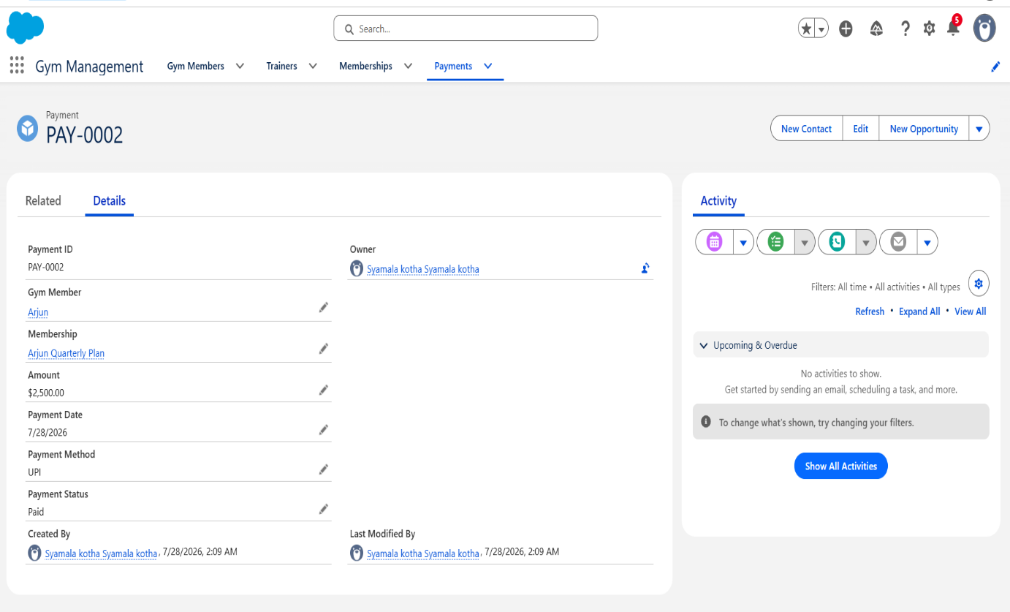
Schema Builder:
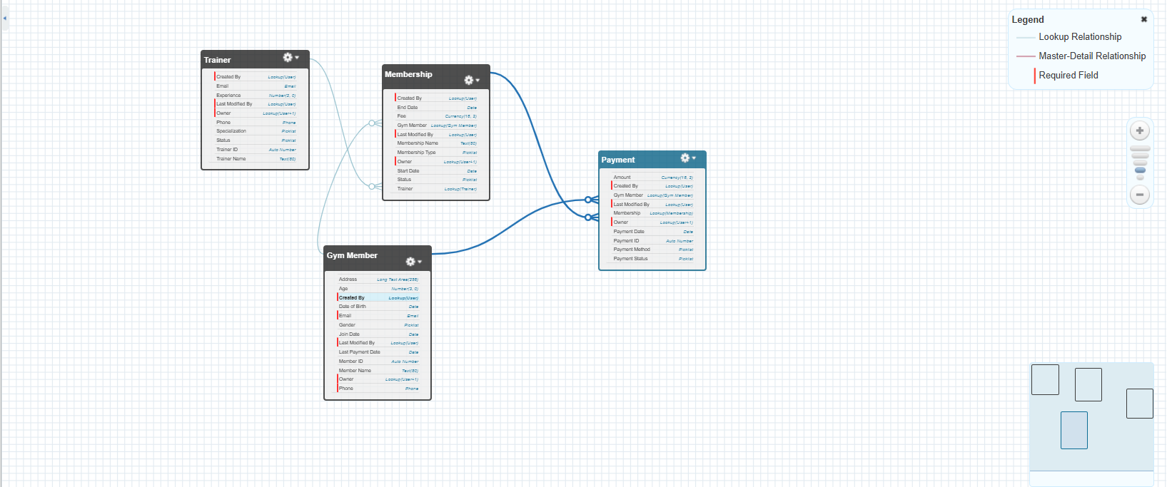
Apex Programming:
Apex is a strongly typed, object-oriented programming language provided by Salesforce. It is used to write custom business logic and automate processes that cannot be achieved using standard Salesforce configuration tools.
Creating Gym Member Record Using Anonymous Apex
Purpose
The following Anonymous Apex code is used to create a new Gym Member record directly from Apex.
This demonstrates:
- Creating an Apex object
- Assigning field values
- Performing insert DML operation
- Displaying the created record Id
Apex Code:
Gym_Member__c member = new Gym_Member__c();
member.Name = 'Rahul Kumar';
member.Phone__c = '9876543210';
member.Email__c = 'rahul@gmail.com';
member.Gender__c = 'Male';
insert member;
System.debug('Gym Member Created: ' + member.Id);
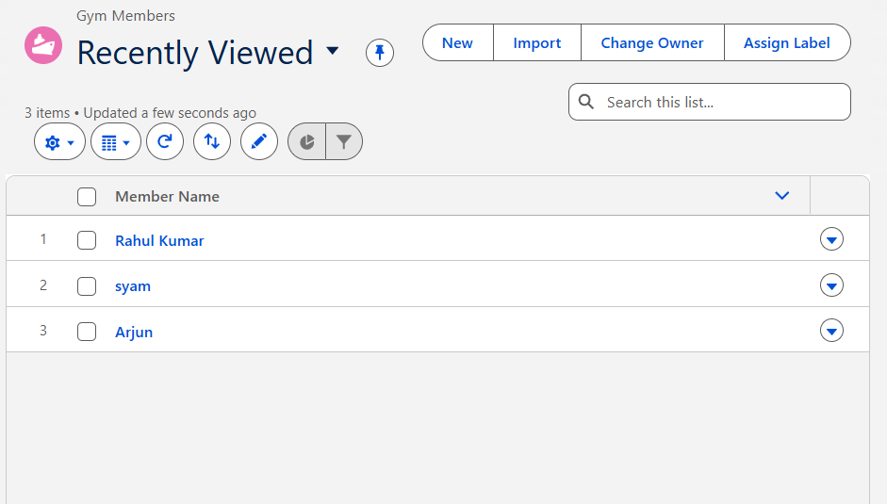
SOQL (Salesforce Object Query Language):
SOQL stands for Salesforce Object Query Language. It is used to retrieve records from Salesforce database objects.
SOQL is similar to SQL but it is specifically designed for Salesforce objects and fields.
Using SOQL, developers can fetch required records based on specific conditions and display the required information.
SOQL Query:
This query retrieves the following fields from the Gym Member object

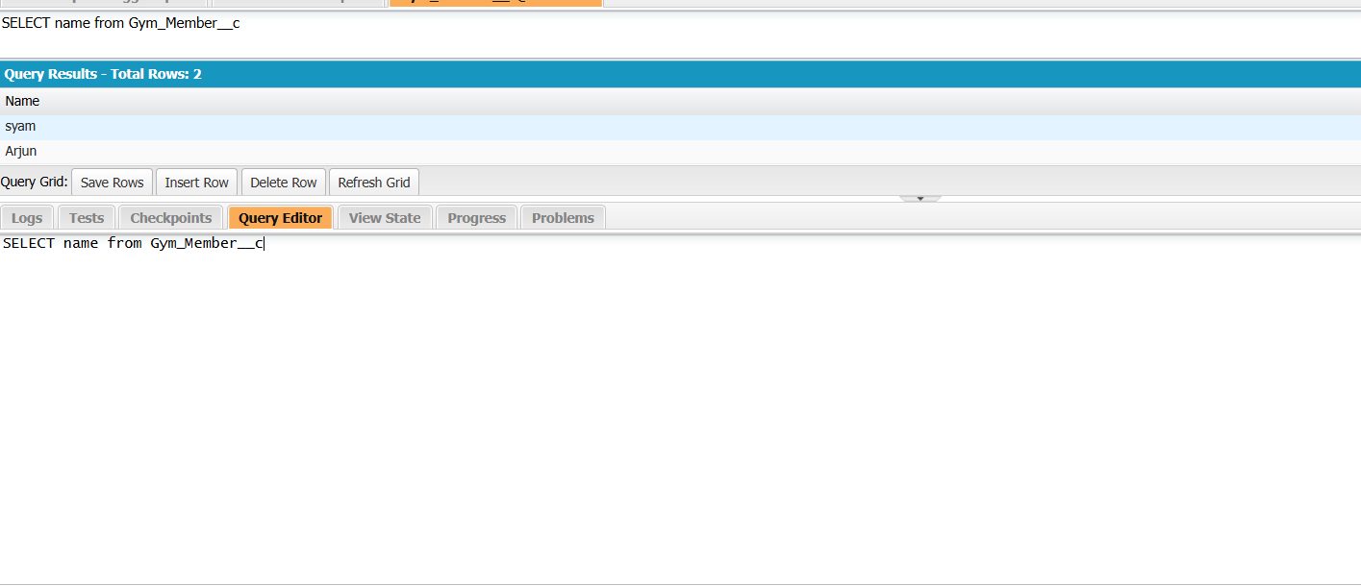

2.Using the Where clause:
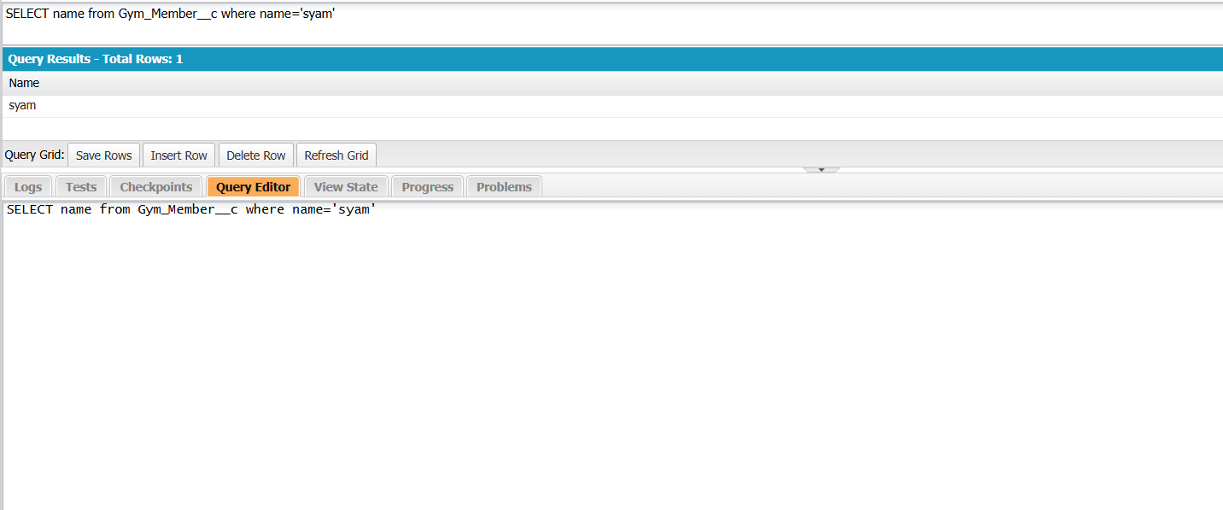
3.Using order by and Limit:
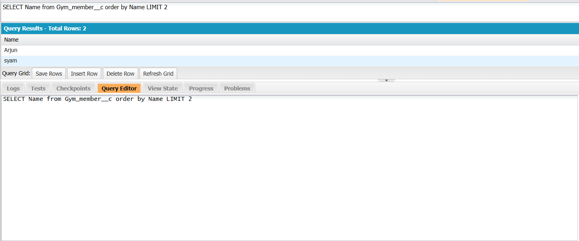
Apex Trigger in Salesforce:
An Apex Trigger is a piece of Apex code that executes automatically when a specific event occurs on a Salesforce object.
Trigger Code:
trigger PaymentTrigger on Payment__c (after insert) {
List<Gym_Member__c> membersToUpdate = new List<Gym_Member__c>(); for(Payment__c pay : Trigger.new){
if(pay.Payment_Status__c == 'Paid'){
Gym_Member__c member = [
SELECT Id, Membership_Start_Date__c,
Membership_End_Date__c
FROM Gym_Member__c
WHERE Id = :pay.Gym_Member__c
];
member.Membership_Start_Date__c = Date.today();
member.Membership_End_Date__c =
Date.today().addMonths(1);
membersToUpdate.add(member);
}
}
if(!membersToUpdate.isEmpty()){
update membersToUpdate;
}
}

